Contents

Joint Probability of A and B / Marginal probability of B 2

Expressing one conditional probability in terms of others conditional probability (Base theorem): 2

Rules to apply base theorem: 3

Prior and posterior probability: 4

Bayes theorem example: 4

Summarizing data: 5

We can apply statistics to only structured data: 6

We cant apply statistics to unstructured data like text, image, audio, video: 6

Examples of Data types: 7

Measure of central tendency: 7

Mean: 8

Median: 8

Mode: 9

Mean, median and mode difference: 9

Measure of Spread: 10

Variance: 10

Range: 10

Summarizing data in coding: 11

Measure of symmetry: 11

Symmetry and Skewness: 12

Positive, negative skewed and normal distribution data: 12

Detection of upper side and lower side outliers: 13

Outliers Detection algorithm: 13

For the symmetry the coefficient of skewness is zero. 14

# Joint Probability of A and B / Marginal probability of B

# Expressing one conditional probability in terms of others conditional probability (Base theorem):

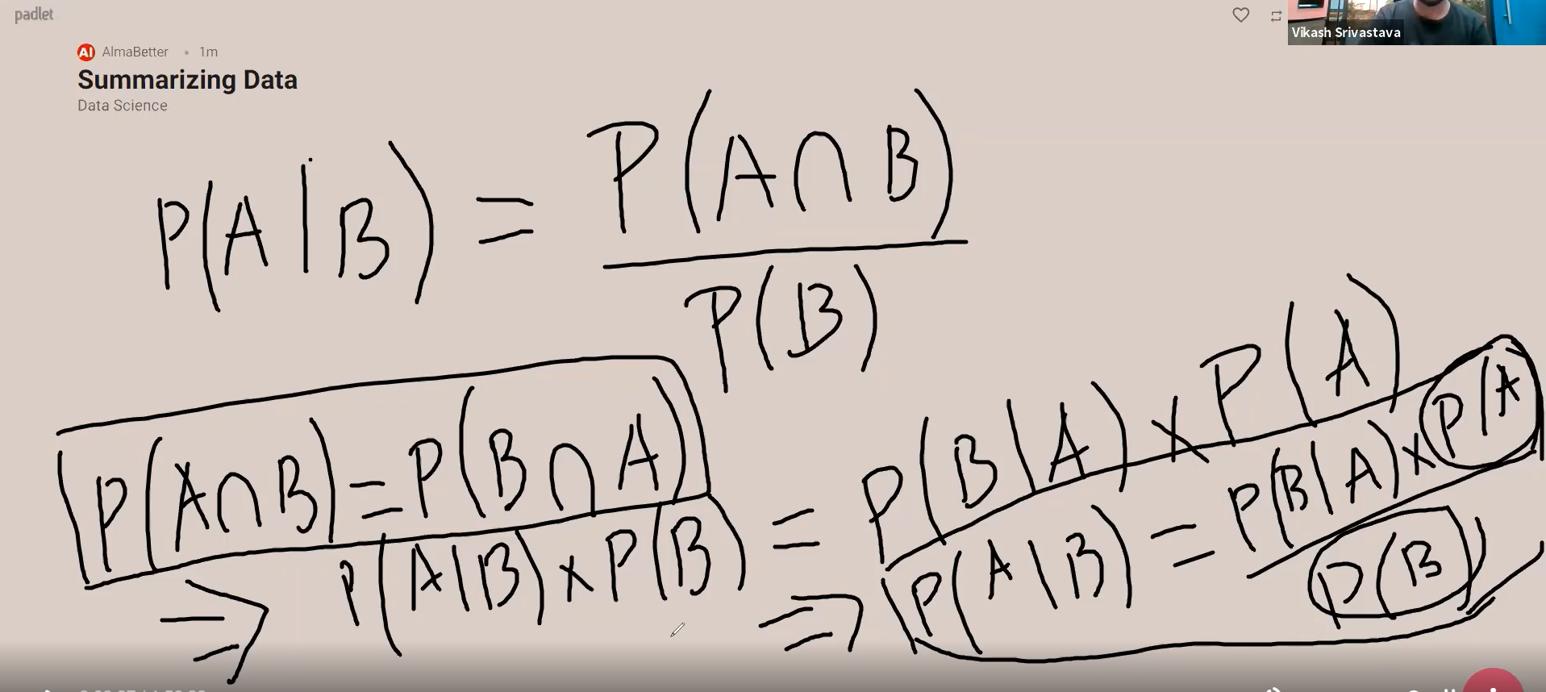

# Rules to apply base theorem:

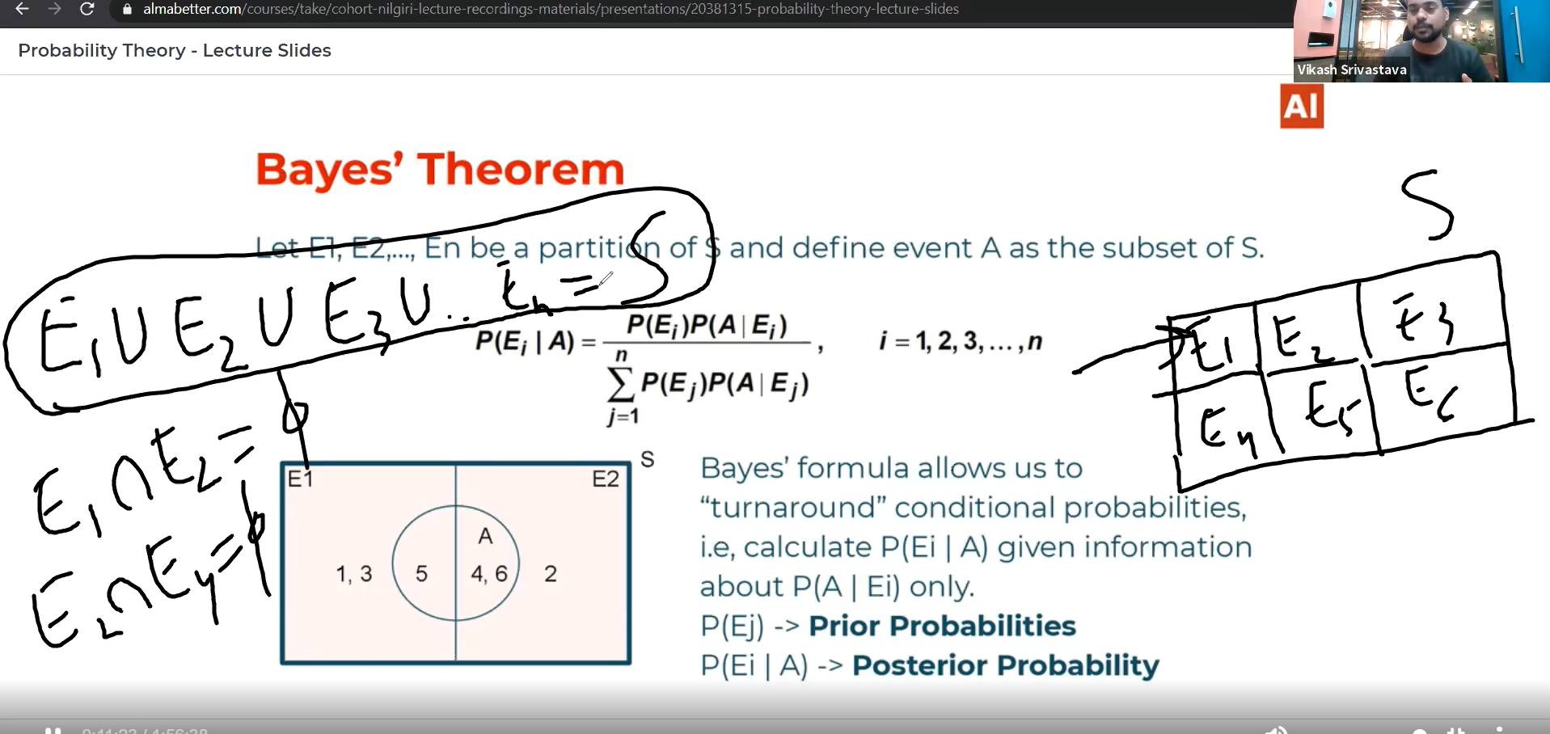

* E1,E2,E3,….., En should be equally distributed and they should be mutually exclusive.
* E1UE2UE3U…..UEn==S(sample space)

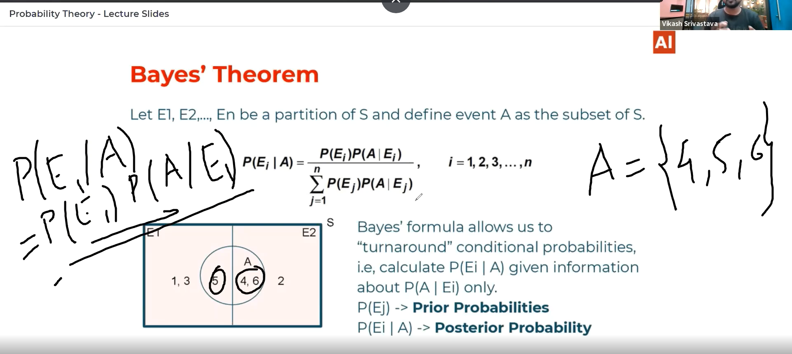

# Prior and posterior probability:

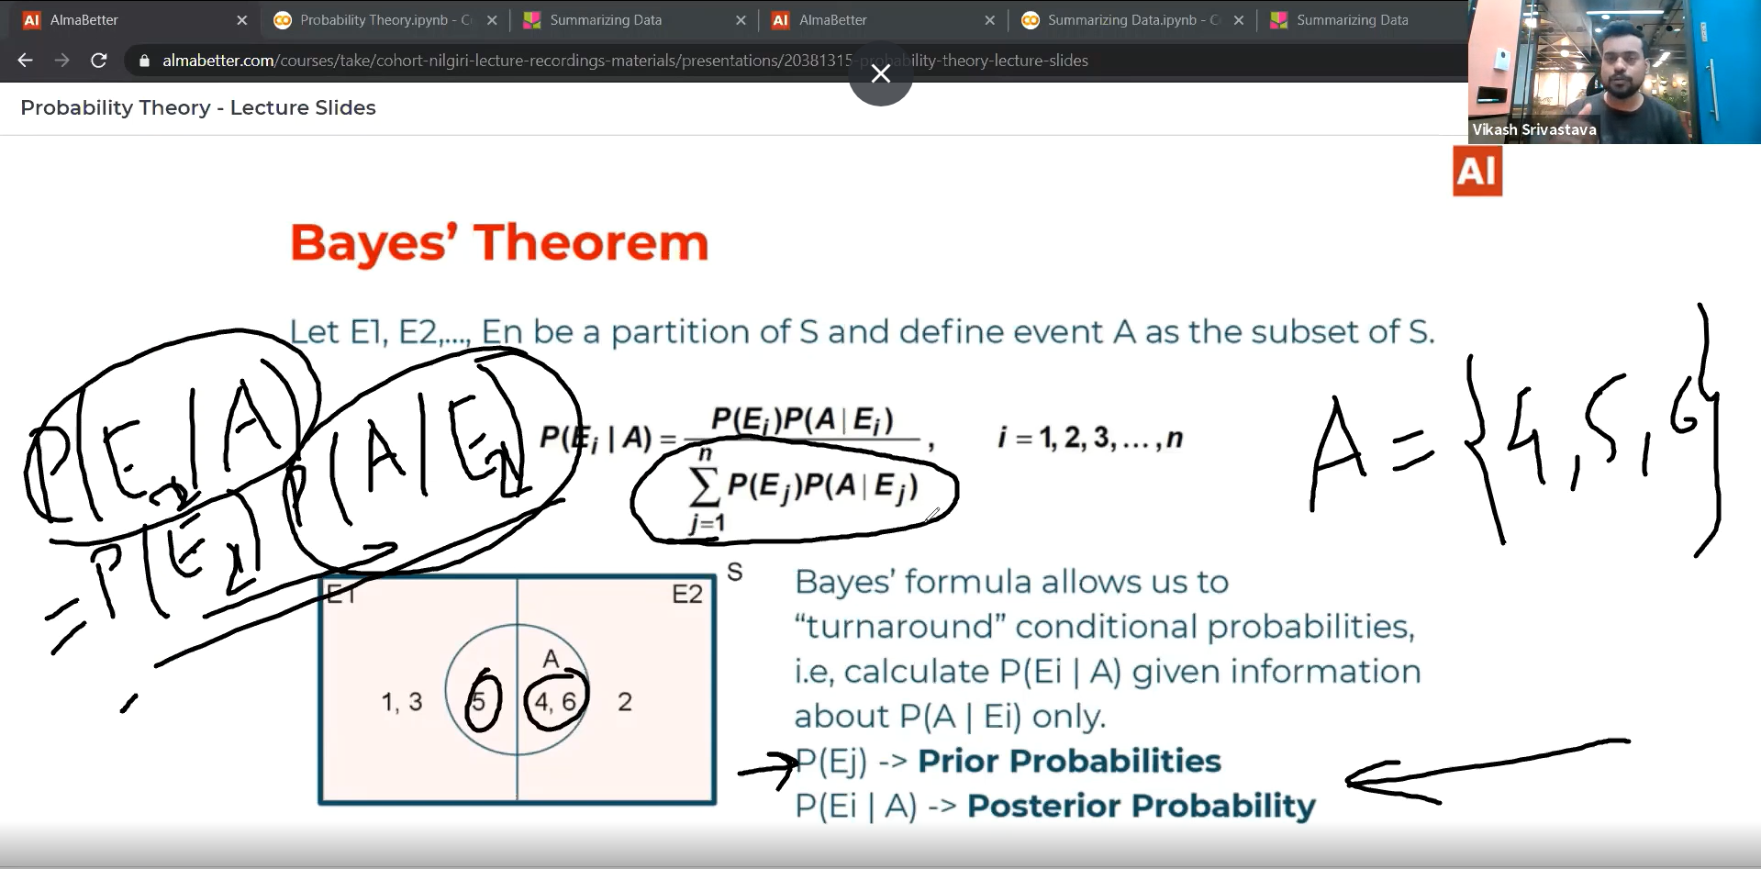

# Bayes theorem example:

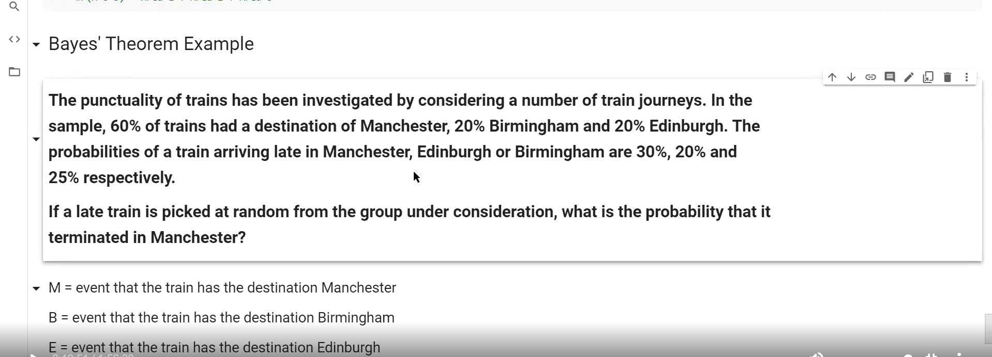

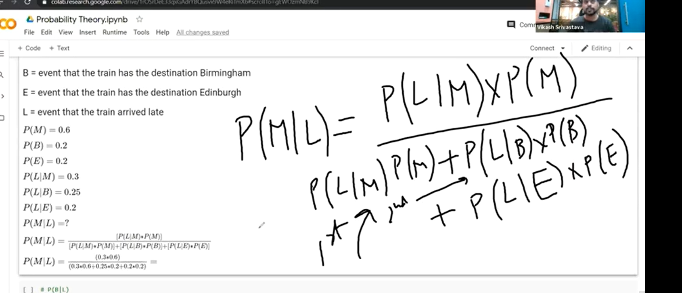

# Summarizing data:

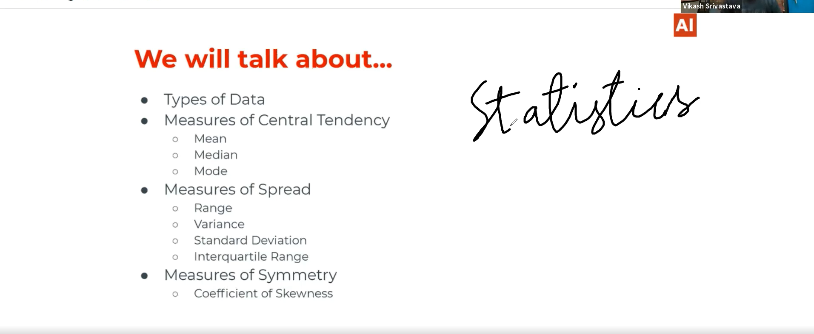

# We can apply statistics to only structured data:

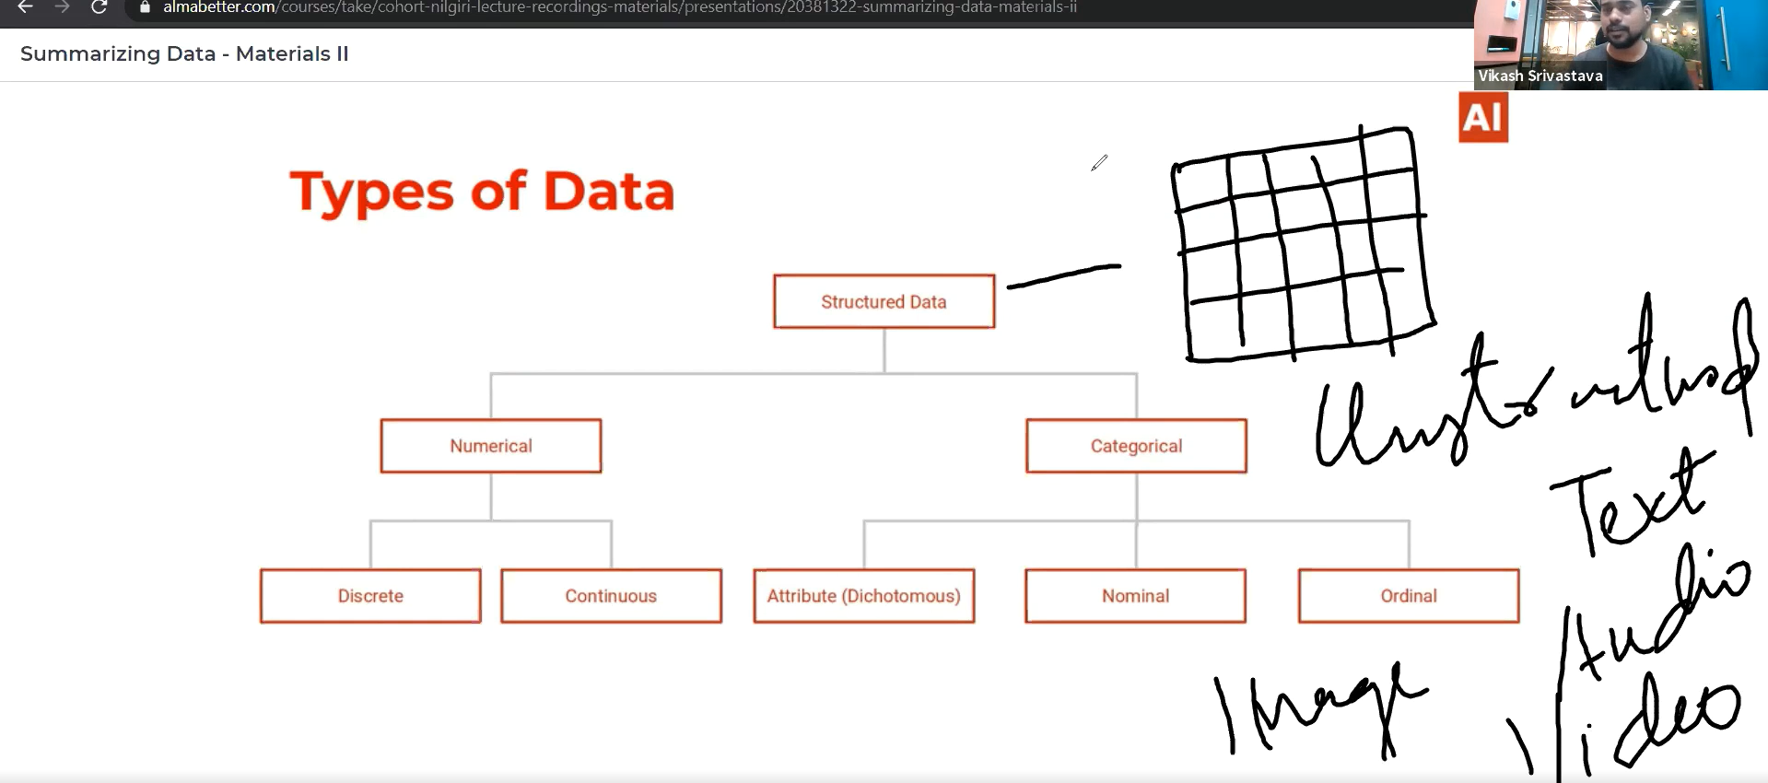

# We cant apply statistics to unstructured data like text, image, audio, video:



Structured data: 🡪 Numerical

🡪 Categorical

Categorical🡪 Attribute(Dichotomous)-> It is a special case of nominal with only 2 categories ex:yes / no.

Nominal🡪 The data without ranking ex: eye color

Ordinal🡪 Categories with meaningful ranking 1 to 5 ranking.

# Examples of Data types:

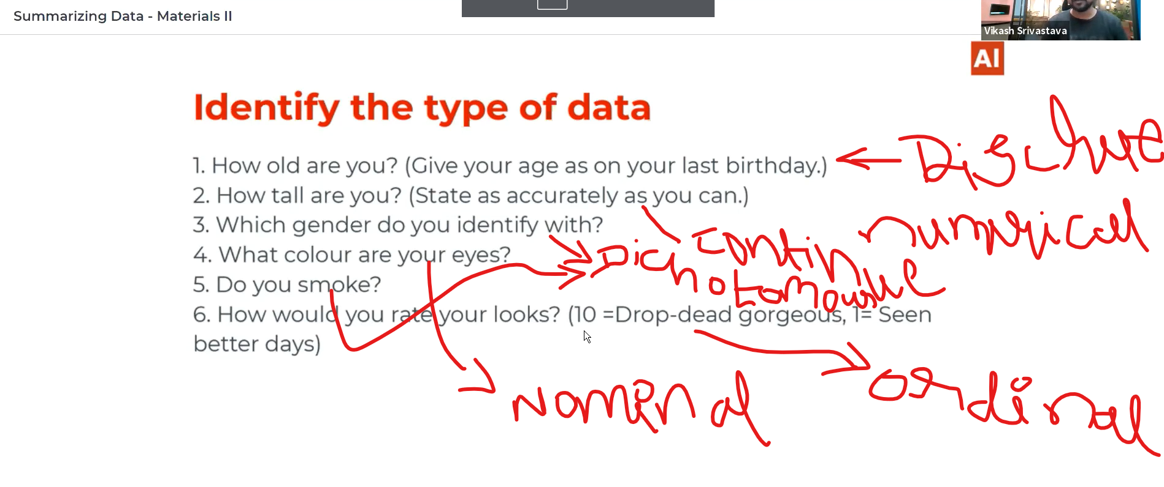

# Measure of central tendency:

It means how would you summarize your data in a good way. Central tendency means entire data tends not one single middle value.

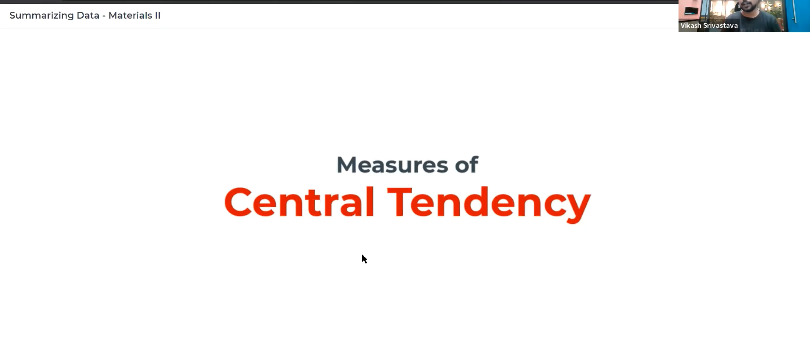

# Mean:

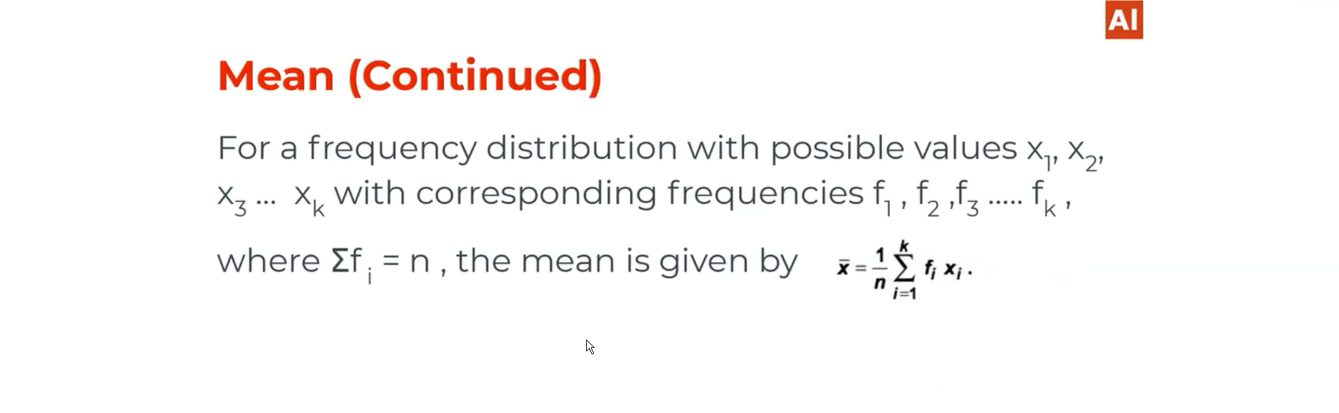

# Median:

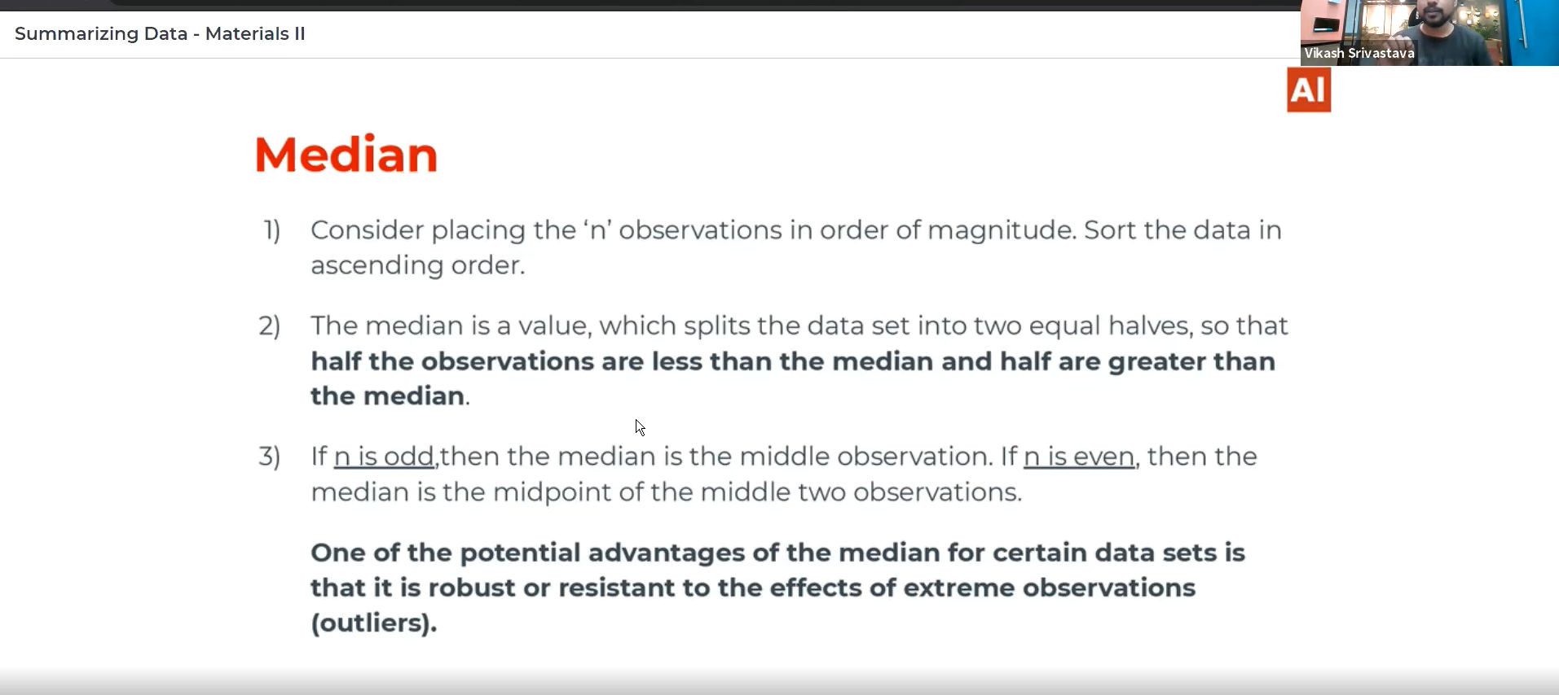

# Mode:

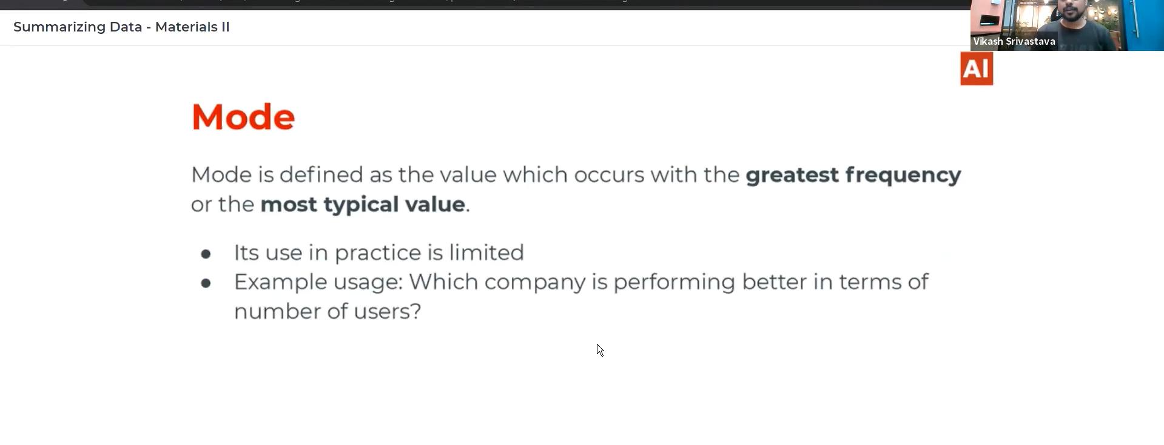

# Mean, median and mode difference:

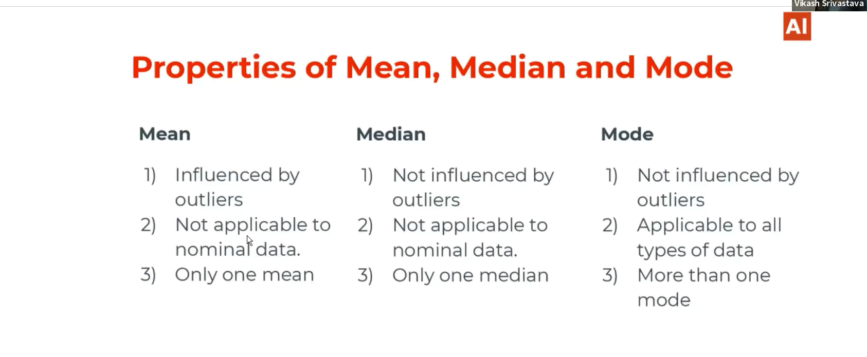

# Measure of Spread:



## Variance:

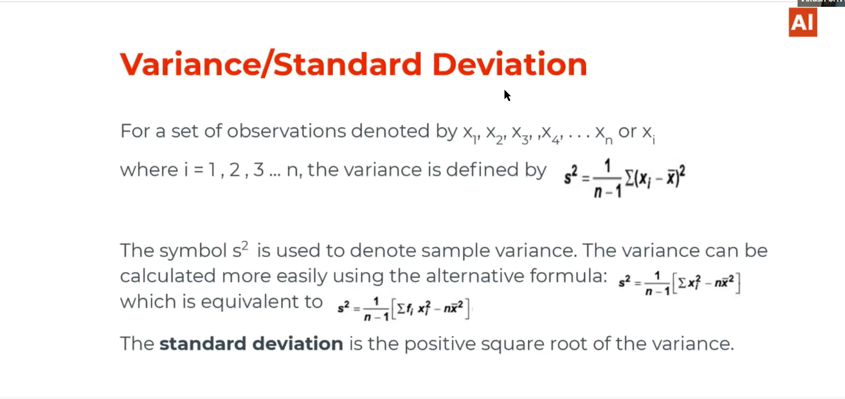

## Range:

Its might be the difference between outliers because It is the difference between the max and min data points in a sample data and the max and min data points in a spread data may be the outlier.

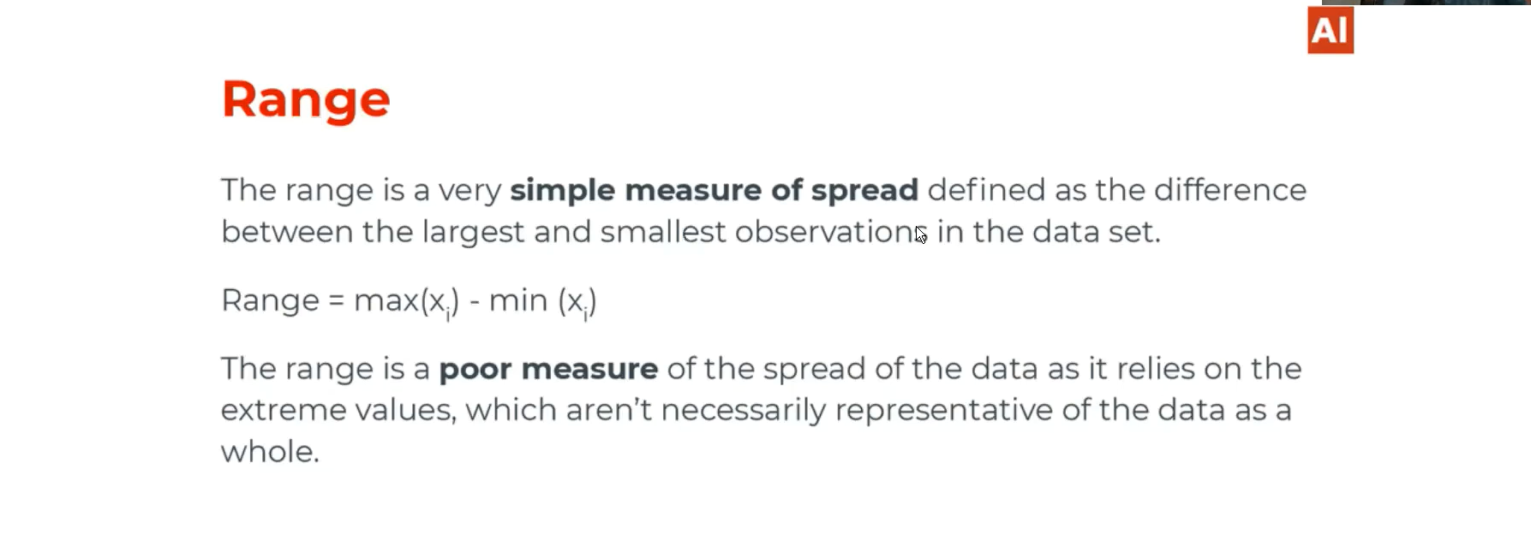

# Summarizing data in coding:

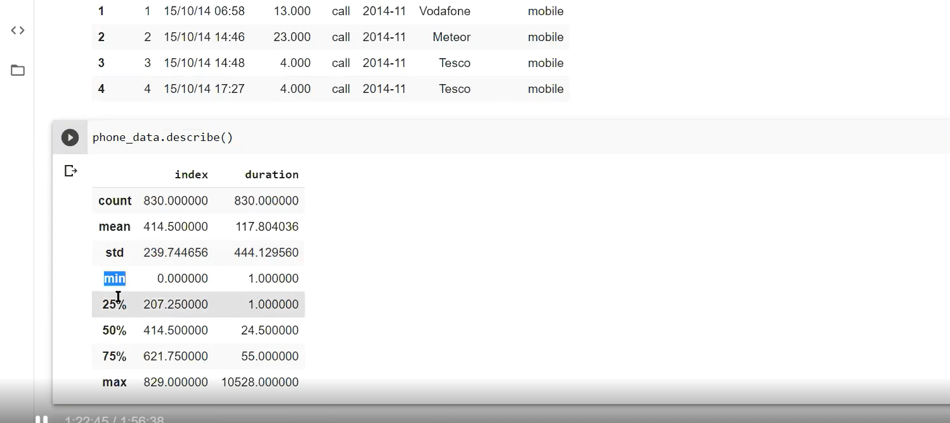

We use box plot to describe the Inter quartile range and summary of data.

# Measure of symmetry:

How the data symmetry is w.r.t central tendency. W.r.t mean.

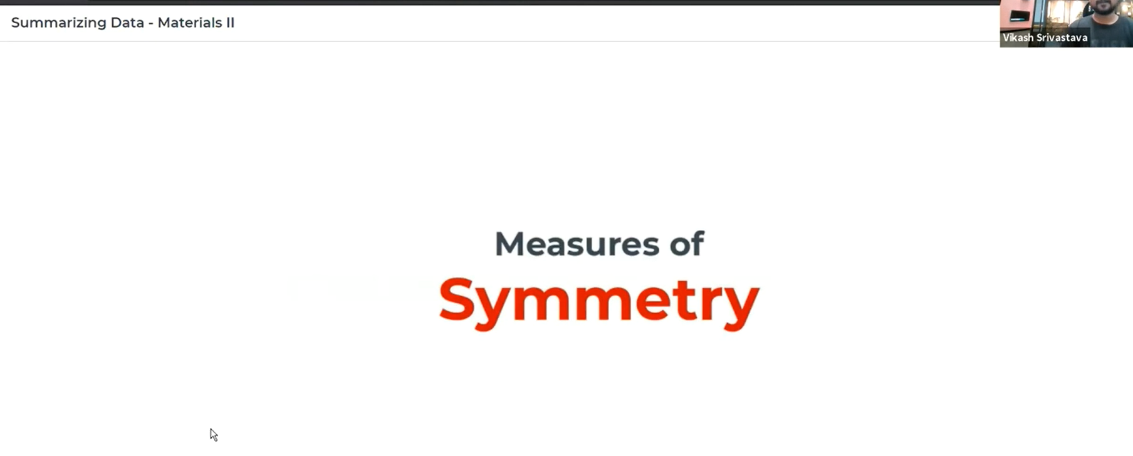

# Symmetry and Skewness:

Most of the data skewed towards right 🡪 Positively skewed

Most of the data skewed towards left🡪 Negatively skewed

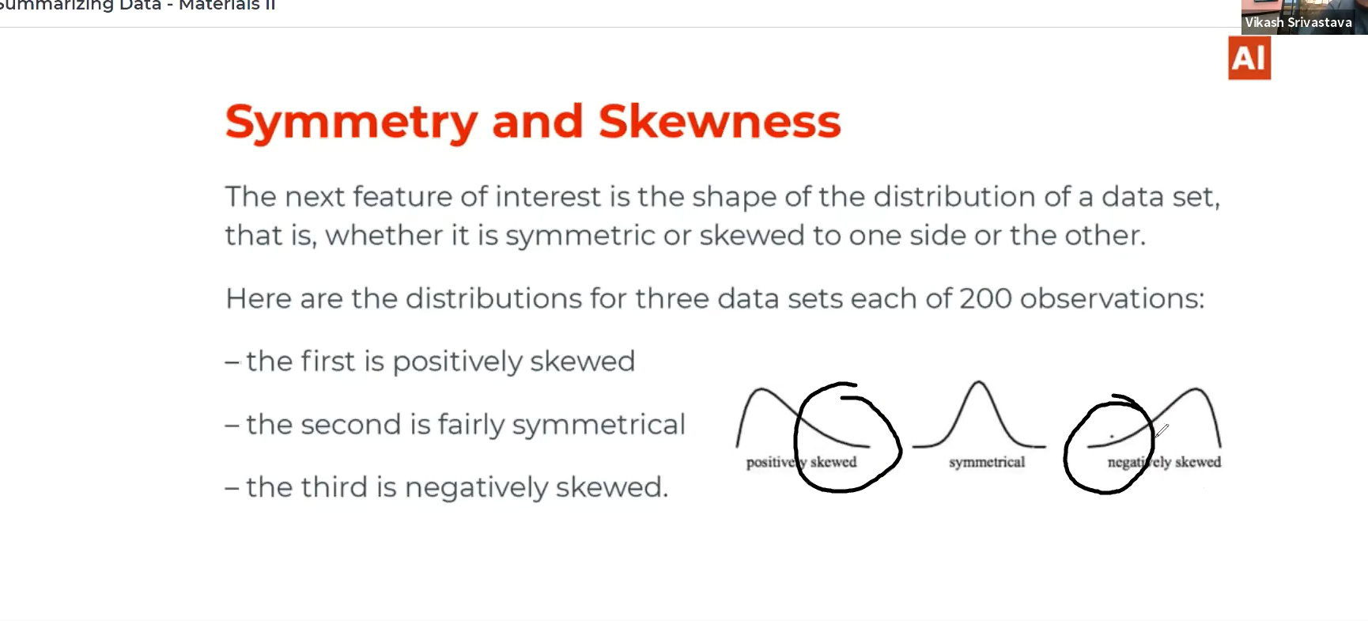

# Positive, negative skewed and normal distribution data:

Positive skewed: The data is normally distributed along both side.

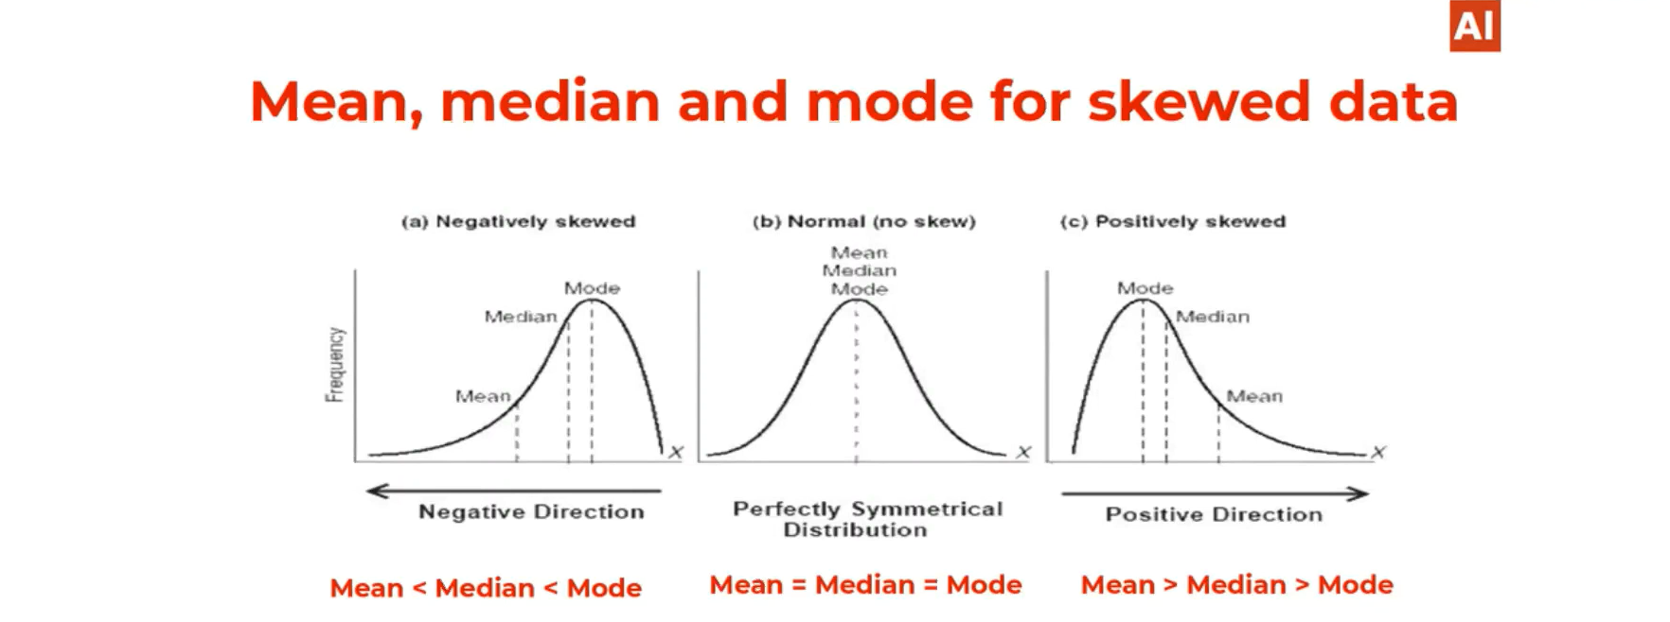

# Detection of upper side and lower side outliers:

If we want to calculate for a specific variable what is the upper side and lower side outlier.

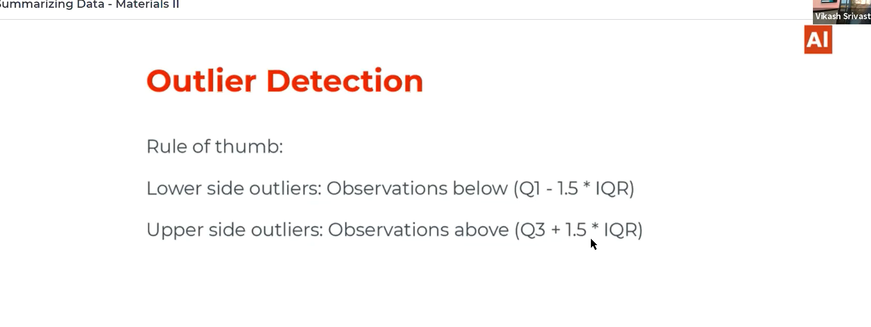

# Outliers Detection algorithm:

Isolation forest

Anything outside the Whiskas are considered as outliers.

# For the symmetry the coefficient of skewness is zero.

